**SOCIETY MANAGEMENT SYSTEM**

**Abstract:**

In this society management system, all the society categorize by the number of houses. The people who live in house they may be an owner of house or tenant of house.  In this era, people are very busy with their routine work, so they do not have time for complain small problem related to houses. We have developed the system for society member so they can make complain form anywhere any time and we resolve the Complain as soon as possible.

In this system people can easily find address of the house by providing member name. The Member of our system can give advertise his house for rent and sell easily through our system by login his login detail.

**Objective:**

* The main purpose of this system is to find out the house for rent and house for buy easily.
* The people can easily find search the rent house or sell house in which society and get contact detail of owner of house.
* All members can make online complain related home to society management.
* Resolving the complaints of society members as soon as possible.

**Structure of Tables:**

Society:

This table contains the details of all the societies such as Society ID, names of societies, addresses of societies, etc.

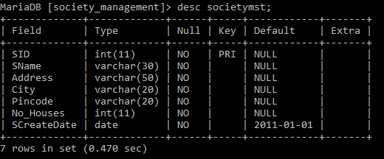

House:

This table contains the details of all the houses such as society name, maintenance per month, house types, etc.

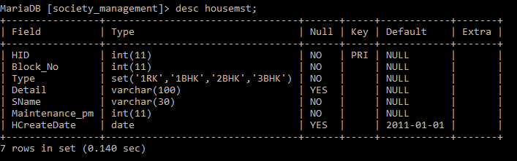

User:

This table contains the details of all the users/ owners, emails, mobile number, members in the house, etc.

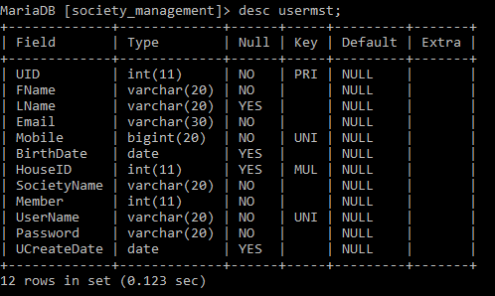

Sell:

This table contains the details of all the selling houses information like society name and ID, user/owner ID, selling price, etc.

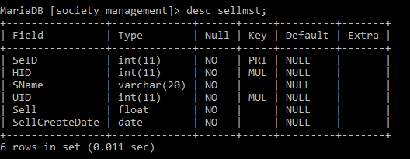

Rent:

This table contains the details of all houses on rent, society name and ID, user/owner ID, rent price, date of rent creation.

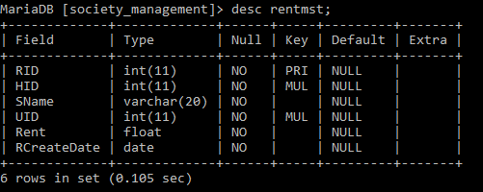

Complain:

This table contains the details of all complaints related to houses and societies, subjects and complaints in the societies, status of complaints and complaint creation date.

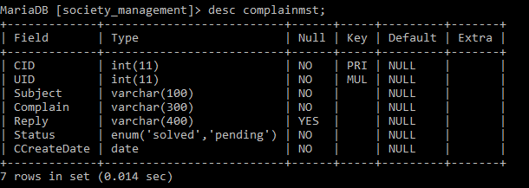

**Contents of Tables:**

Society:

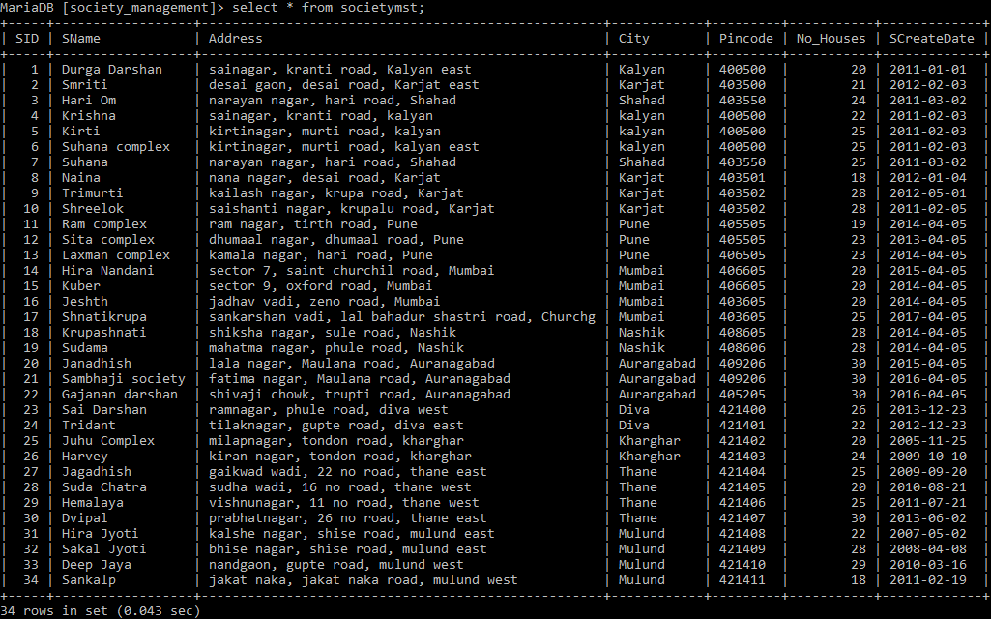

House:

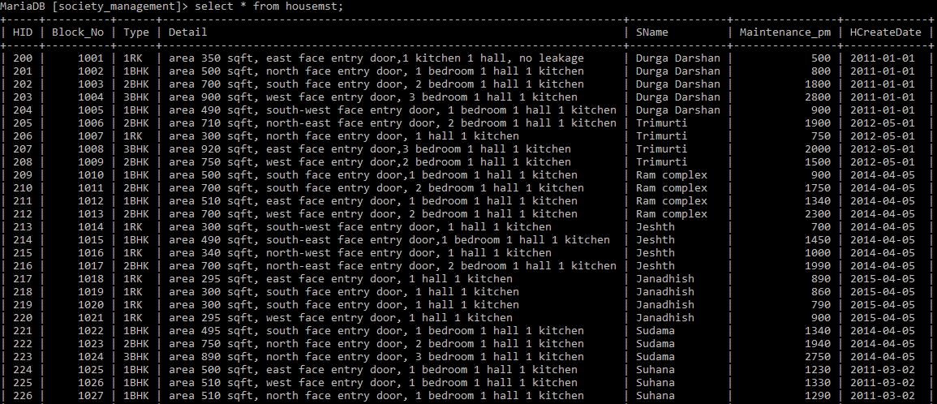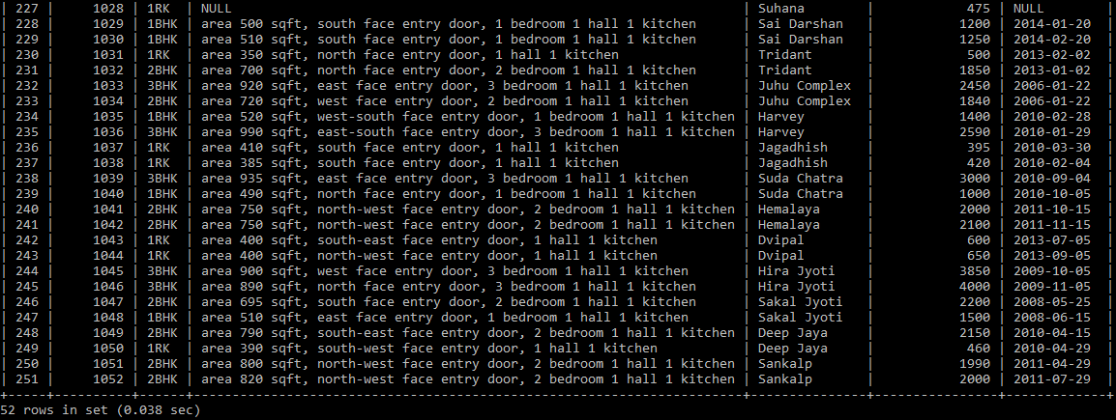

User:

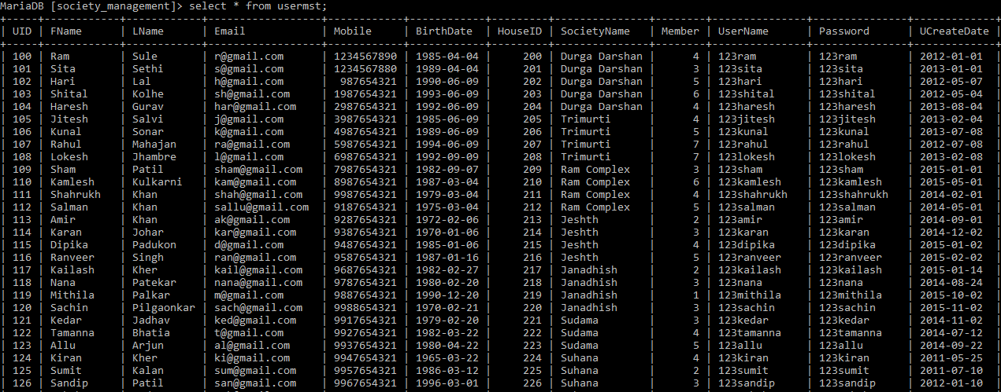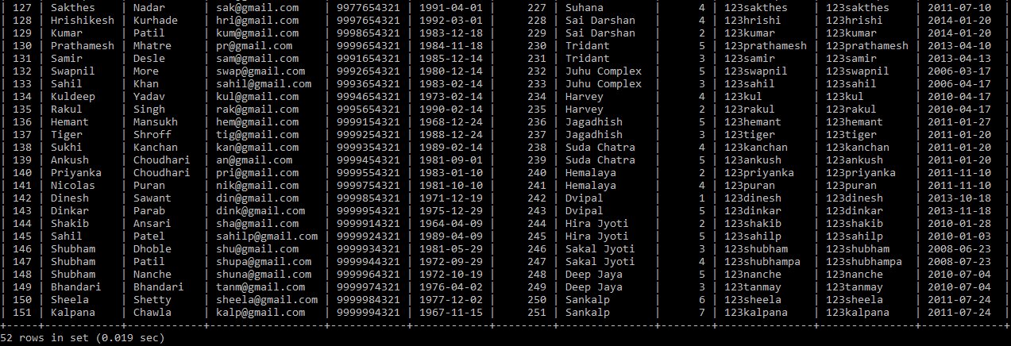

Sell:

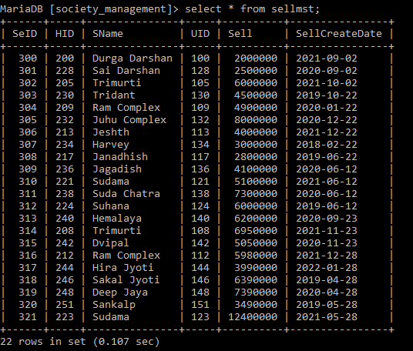

Rent:

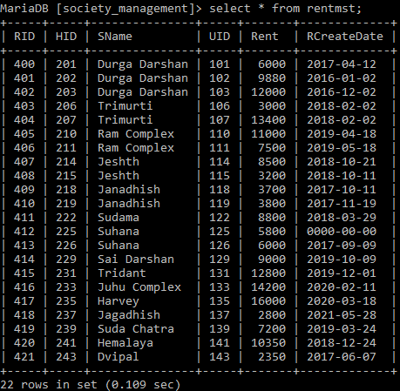

Complain:

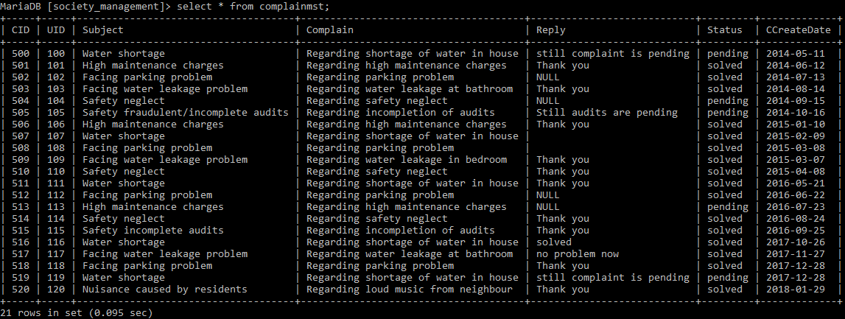

**Subqueries:**

Find the name of the user who sell house for 20,00,000.

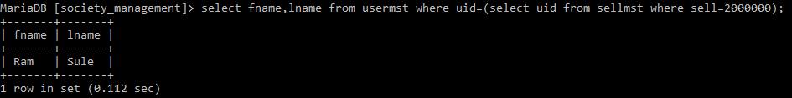

Find the details of the owner/user who wants to give house on rent from Ram Complex society and Suda Chatra society.

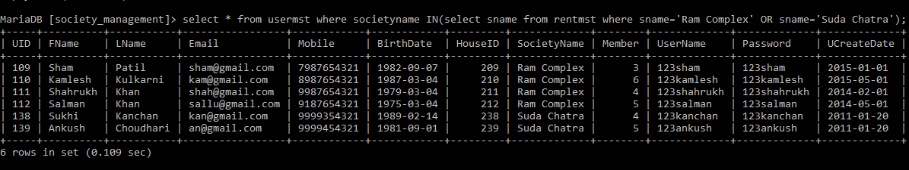

Find the users/owners name whose complaints are still pending.

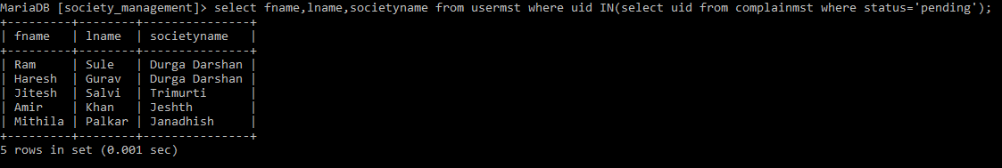

Find the users whose house of rent is more than 10,000.

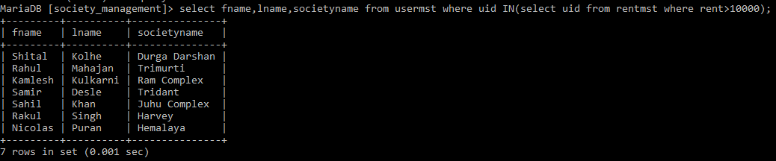

**Views:**

Create view rent as available_on_rent.



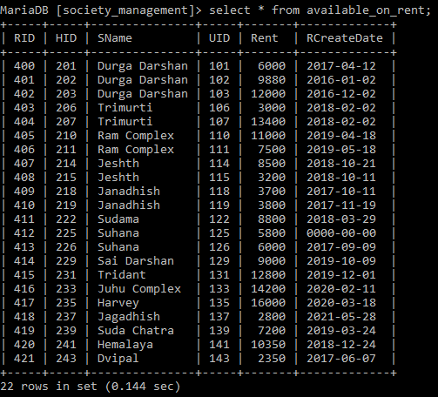

Create table view which shows rent price of houses including their societies.

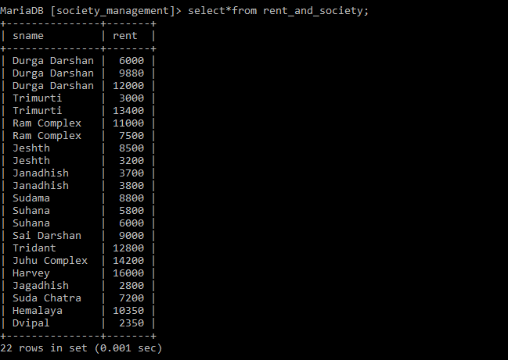

Create view table about society names and their addresses.

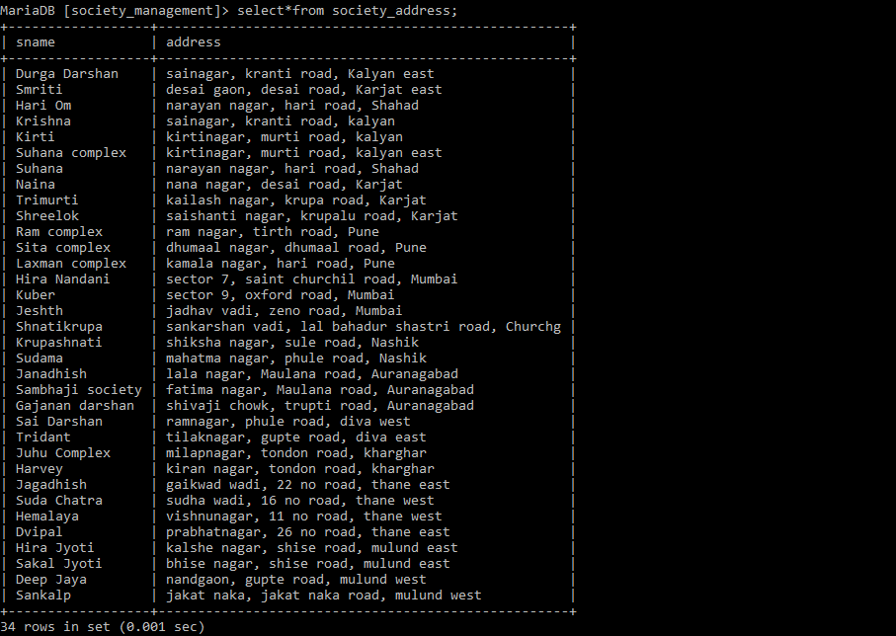

Create and Drop view table which has not records columns. (rent and sell)

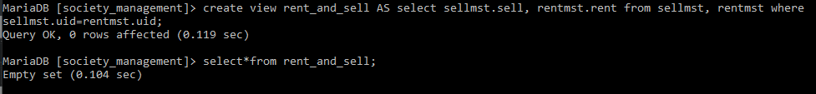 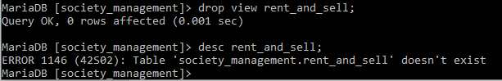

**Joins:**

Display only important details from house for sell and their complains.

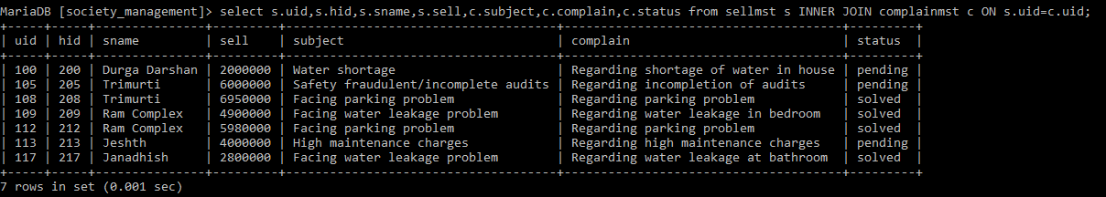

Create Left join which display uid, society names, rent prices, subject of complaints and complains from rent and complain tables.

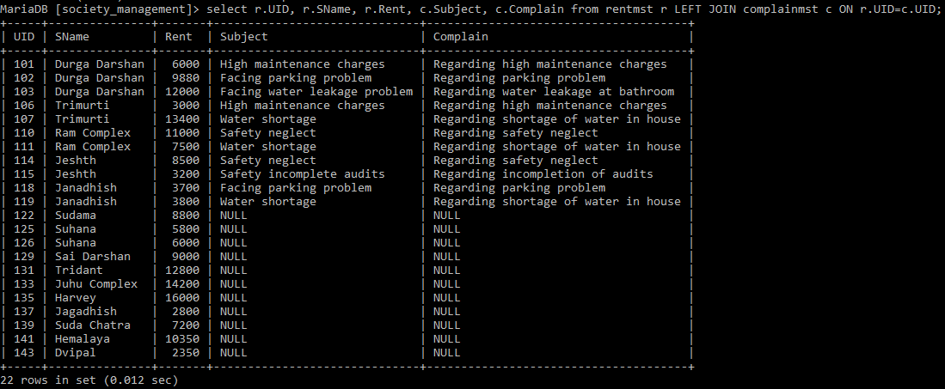

Create Right join which display uid, society names, rent prices, subject of complaints and complains from rent and complain tables.

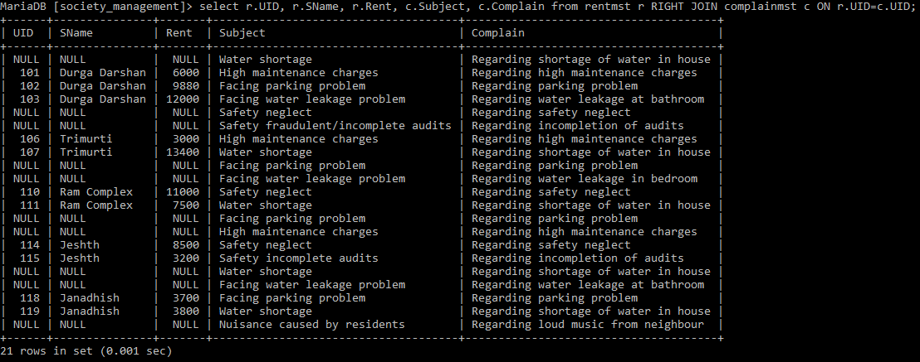

Create Cross join to see houses on sell and their complains from sell and complain table.

Equijoin:

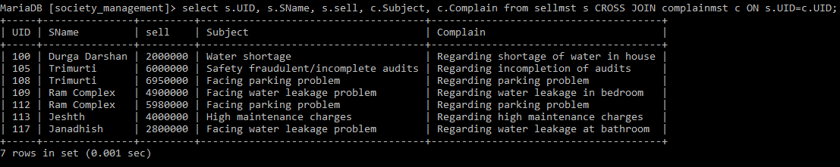

Non-Equijoin:

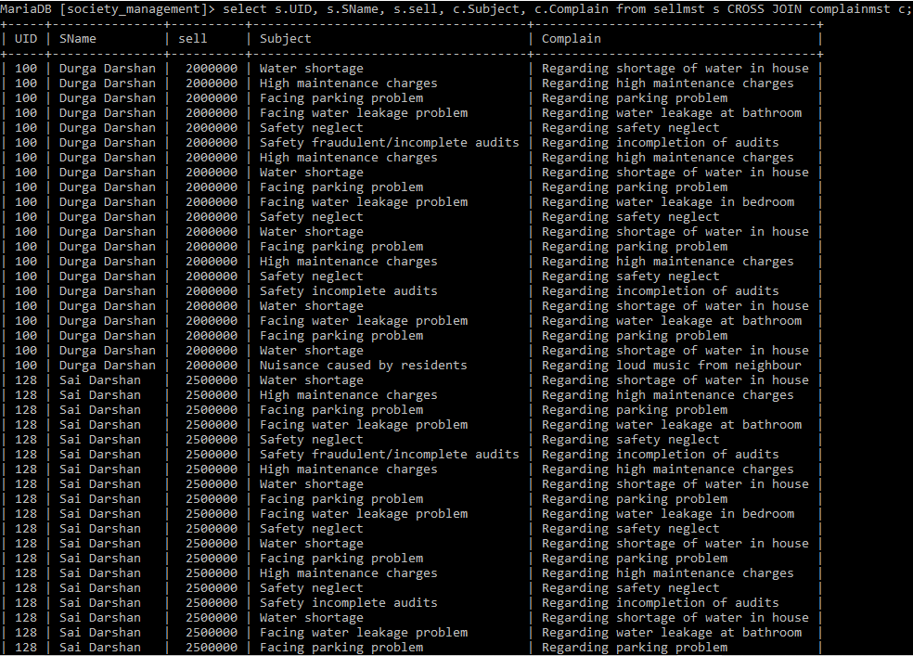 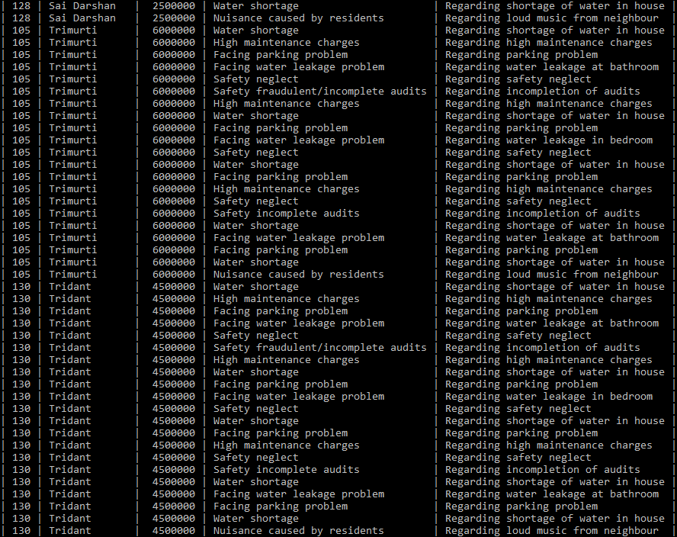 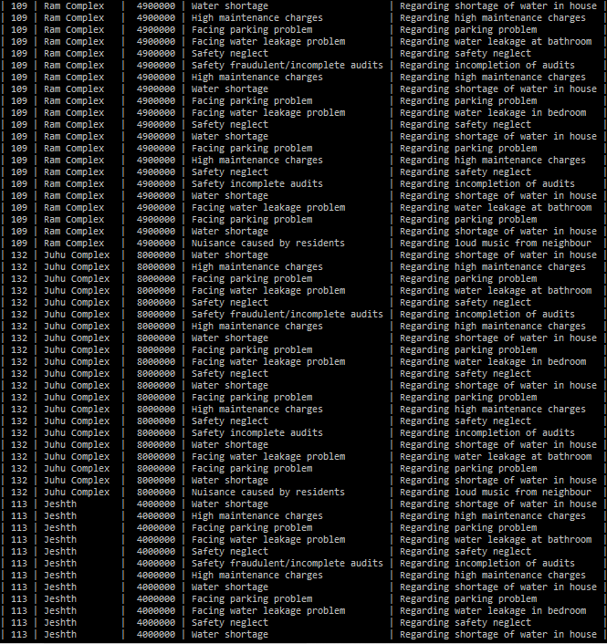 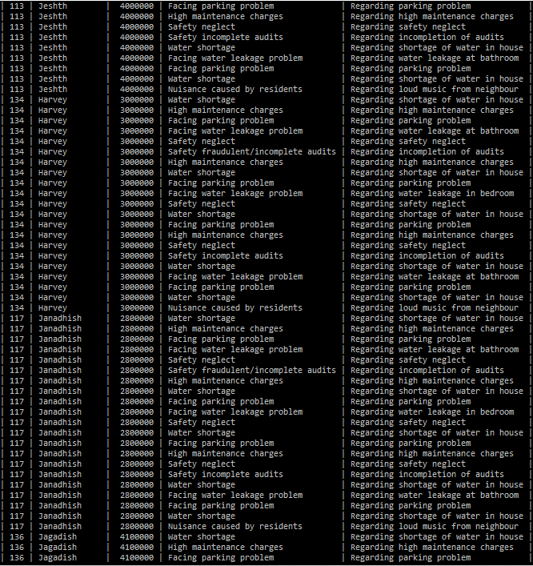 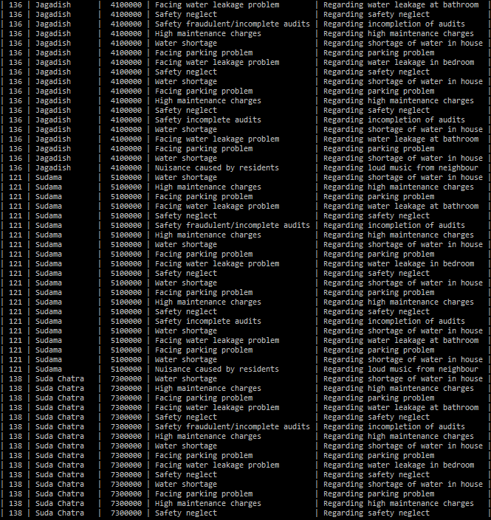 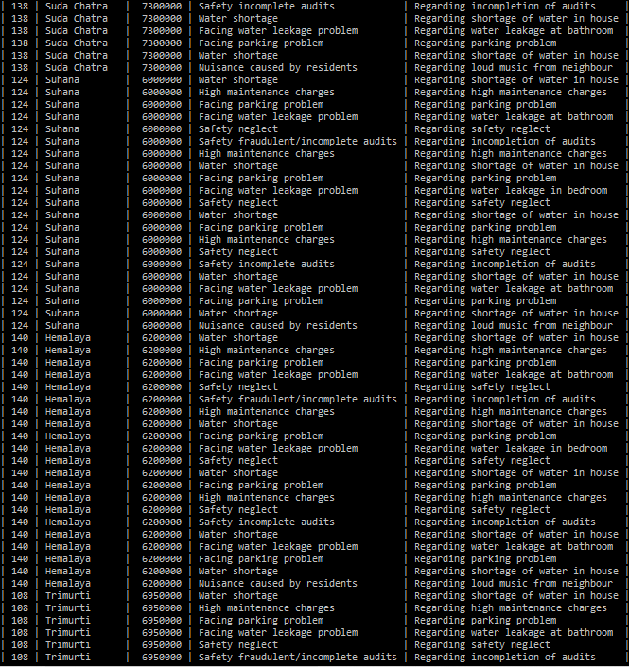 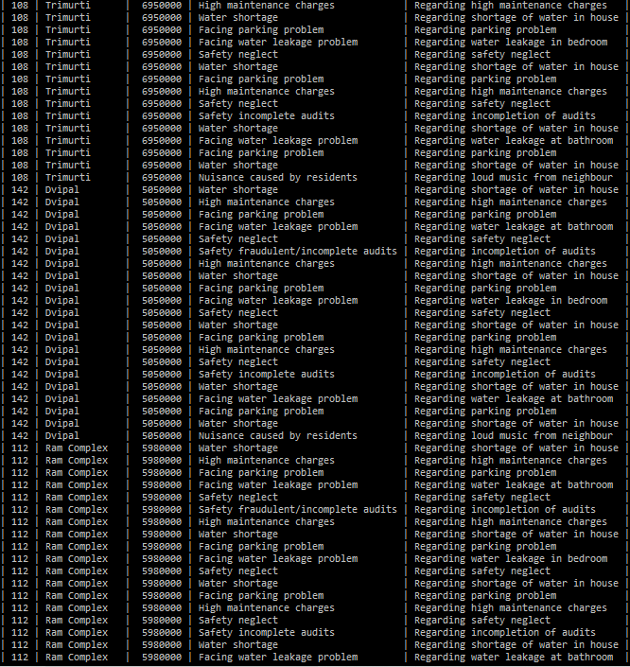 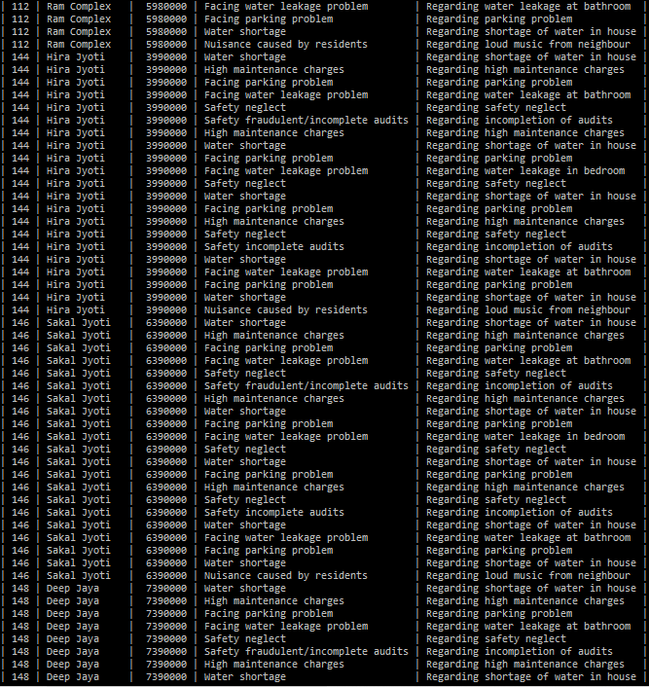 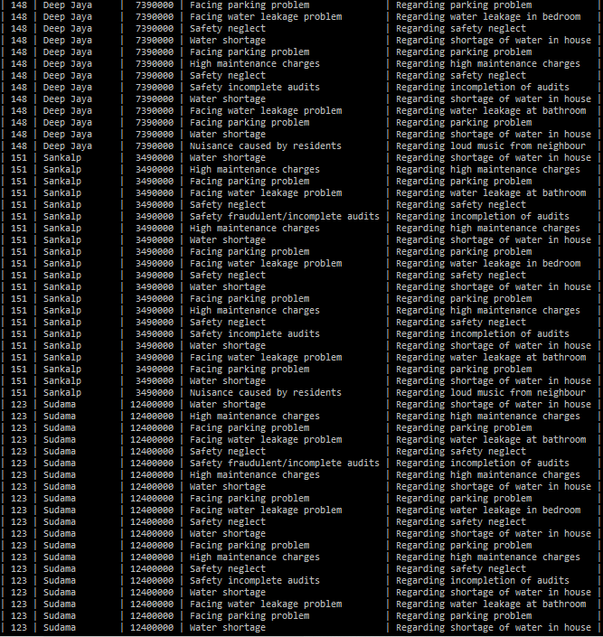 

Create UNION of society and house table

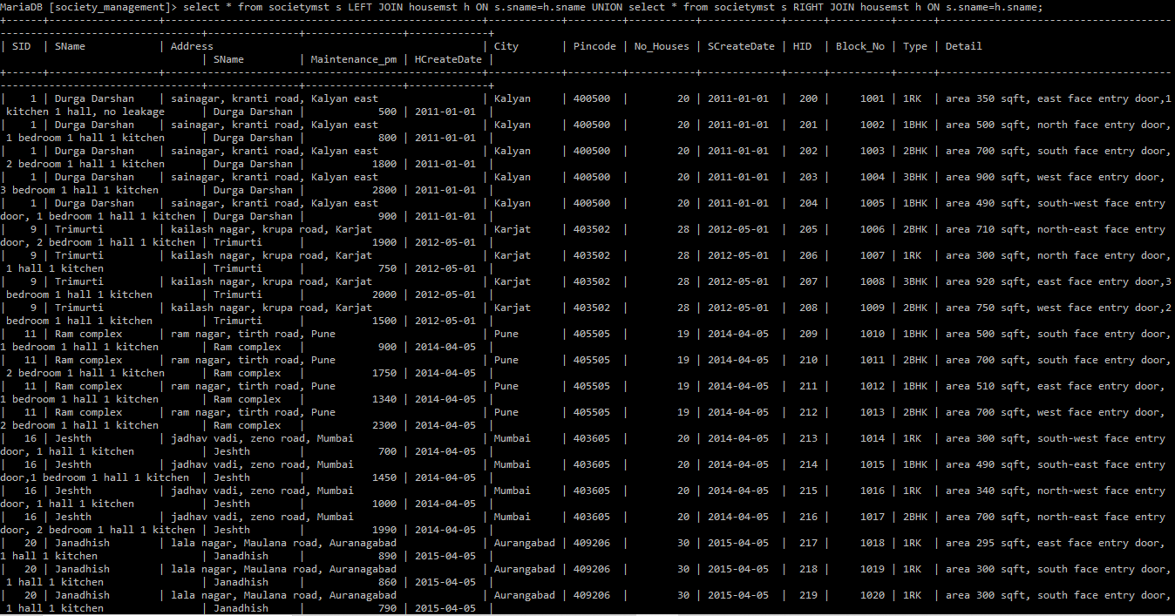 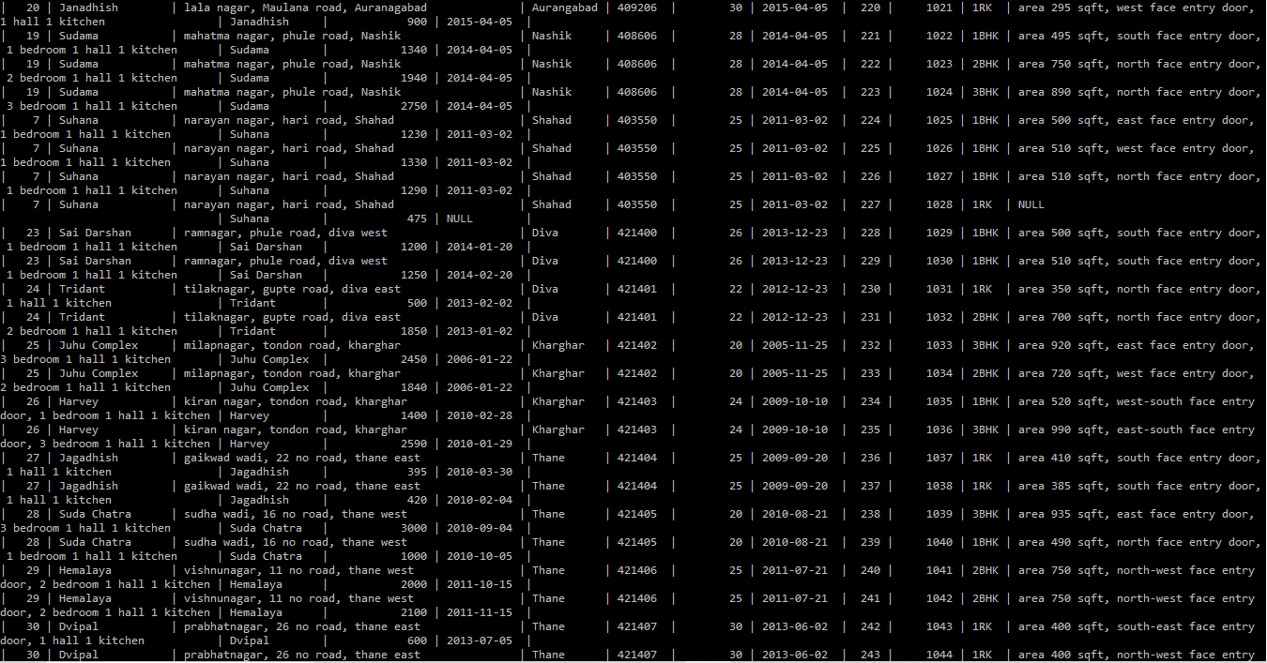 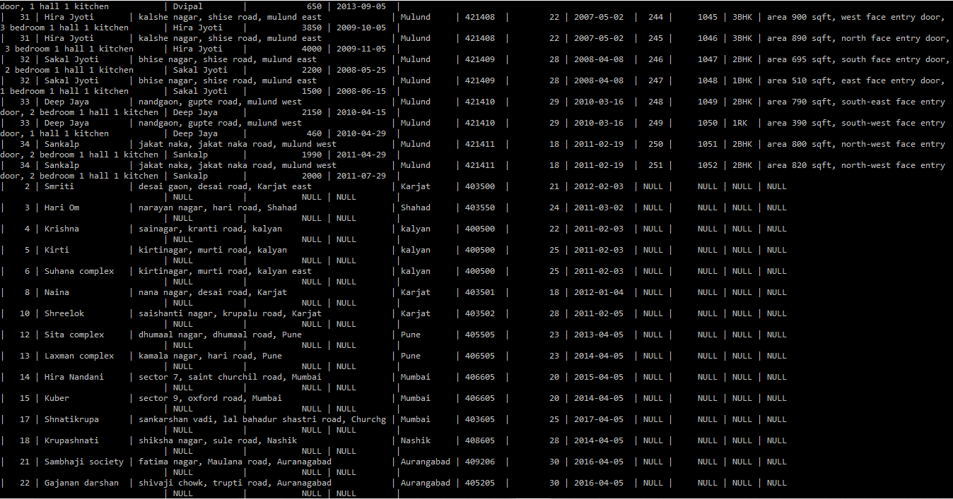

Create Self join on sell table.

